Business Analysis Plan

| **PPM #** |  | **Project Name** | |  |
| --- | --- | --- | --- | --- |
| **Author** |  | **Date** |  | |

**The contents of this business analysis plan are based off Project Management Institute standards. A business analysis plan defines the approaches used across the Business Analysis Knowledge Areas.**

**Table of Contents**

Introduction 2

Stakeholder Engagement and Communication Approach 3

Stakeholder Register 5

Stakeholder Engagement 5

Communication Approach 5

Elicitation Approach 6

Finding Information 7

Prepare for Elicitation 7

Example of Preparation Notes for an Elicitation Session 8

Elicitation Techniques 8

Analysis Approach 10

Create and Analyze Models 11

Acceptance Criteria 12

Requirements Management 14

Verify Requirements 15

Validate Requirements 15

Prioritize Requirements and Other Product Information 16

Product Risk Management 18

Identify and Analyze Product Risks: Tools and Techniques 18

Traceability and Monitoring Approach 20

Solution Evaluation Approach 23

References 26

Sign-off 27

# Introduction

Conducting Business Analysis Planning is the process performed to obtain shared agreement regarding the business analysis activities a project team will perform, and the assignment of roles, responsibilities, and skill sets for the tasks required to successfully complete the business analysis work. The results of this process are assembled into a business analysis plan that may be formally documented and approved or may be less formal depending on how the team operates. Whether the plan is formally documented or not, the results from all the planning processes should be considered in the overall approach. Failing to make planning decisions can result in a less than optimal approach when performing the business analysis work. The key benefit of this process is that it sets expectations by encouraging discussion and agreement on how the business analysis work will be undertaken and avoids confusion regarding roles and responsibilities during execution.

The inputs, tools and techniques, and outputs of the process are depicted in Figure 1-1. Figure 1-2 depicts the data flow diagram for the process. 

**Figure 1-1. Conduct Business Analysis Planning: Inputs, Tools and Techniques, and Outputs**

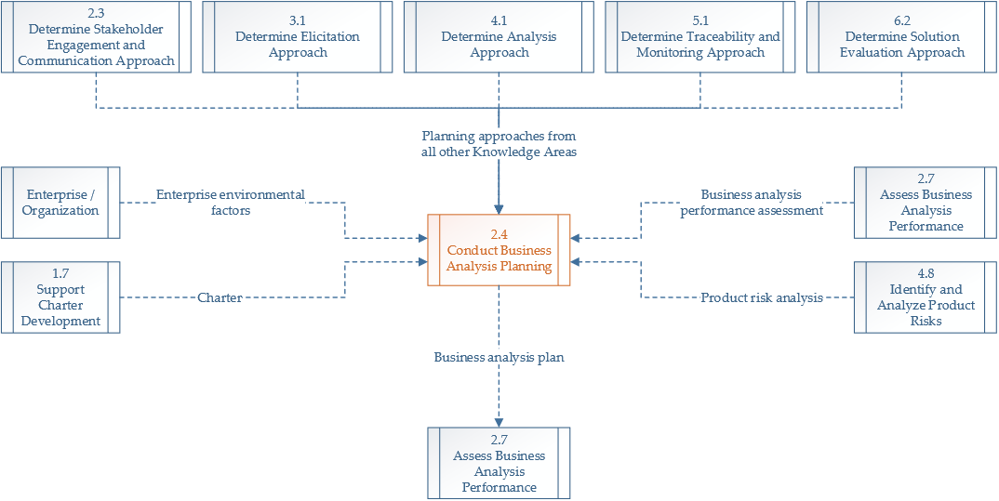

**Figure 1-2. Conduct Business Analysis Planning: Data Flow Diagram**

The process of conducting business analysis planning has two main objectives:

1. Combines all the Knowledge Area approaches into a cohesive decision on how business analysis will be conducted.
2. Estimates the level of effort for business analysis activities.

The activities associated with business analysis planning are accomplished in markedly different ways for efforts that use a plan-driven, predictive life cycle as opposed to those using a change-driven, adaptive life cycle.

When developing the business analysis plan, it is a good practice to provide explanations for the planning choices made. For example, for projects using an adaptive life cycle, the depth and cadence of analysis activities will be planned differently from projects that use a predictive life cycle. Explaining why planning choices were selected provides context for those who review the plan and provides a rationale for the decisions made.

# Stakeholder Engagement and Communication Approach

The Stakeholder Engagement and Communication Approach is the process of developing appropriate methods to effectively engage and communicate with stakeholders throughout the product life cycle, based on an analysis of their needs, interests, and roles within the business analysis process. The key benefit of this process is that it provides a clear, actionable approach to engage stakeholders throughout business analysis and requirements-related activities, so that stakeholders receive the right information, through the best communication methods and frequency to satisfy the needs of the initiative and meet stakeholder expectations.

The inputs, tools and techniques, and outputs of these processes are depicted in Figure 2-1. Figure 2-2 depicts the data flow diagram for the process. 

**Figure 2-1. Determine Stakeholder Engagement and Communication Approach: Inputs, Tools and Techniques, and Outputs**

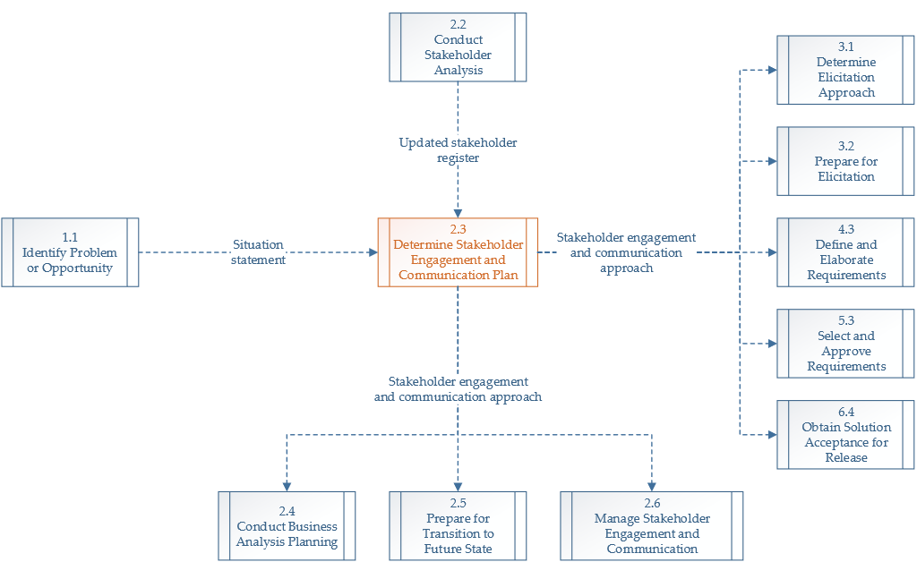

**Figure 2-1. Determine Stakeholder Engagement and Communication Approach: Data Flow Diagram**

Stakeholders should be engaged early and often throughout the life cycle. Stakeholder analysis is often conducted during the planning domain, so the project team can understand the stakeholder impacts and influences on the requirements process as early as possible. This analysis is performed iteratively and is revisited throughout the project as new stakeholders are discovered or existing stakeholders are determined to no longer be impacted by the proposed solution. Lack of stakeholder analysis and engagement may lead to incomplete, incorrect, or missed requirements.

## Stakeholder Register

PMO Business Analysts are encouraged to use the [UFIT Business Analysis Workbook](https://it.ufl.edu/media/itufledu/pmo/templates/UFIT-Business-Analysis-Workbook-Template.xlsx) template to generate a Stakeholder Register. To avoid duplication of documentation and effort, please provide a link to the project’s Business Analysist Workbook below.

[INSERT HYPERLINK HERE]

Once the stakeholder register is complete, stakeholder analysis should be done. Once stakeholder characteristics are understood, then groups can be created to better manage meetings. Groupings can be structured by similar interests, common needs, level of importance, etc., and are used to identify groups for requirements elicitation. It is important to notate the level of influence and impact a stakeholder may have on decisions within the Stakeholder Register. As stakeholders change over the course of the project, the register is updated to reflect the current stakeholders.

## Stakeholder Engagement

Through proactive communication and working directly with stakeholders to meet the project objectives, stakeholders are engaged and managed throughout the requirements life cycle process. It is important to understand their needs and expectations, address issues as they arise, and foster the appropriate engagement throughout the life cycle in order to gain increased support and reduced resistance, significantly increasing the change to achieve project success.

The project’s business analyst and business relationship manager shall attend regularly scheduled meetings with the stakeholder representatives and project team. These individuals shall collect and document business processes, use cases/user stories, and requirements. They shall also manage interactions between the stakeholders and project team to ensure consistency of information.

## Communication Approach

The business analyst shall ensure that all communications are completed as planned. The communications strategy is based on input from stakeholder managers and service owner/manager to target the appropriate customer groups. All communications shall have a clearly defined purpose for effectiveness.

The Communication Plan can be found within the project’s UFIT Business Analysis Workbook. To avoid duplication of documentation and effort, please provide a link to the project’s Business Analysist Workbook below.

[INSERT HYPERLINK HERE]

# Elicitation Approach

The Elicitation Approach outlines how elicitation activities will be conducted, which stakeholders will be involved, which techniques may be used, and the order in which the elicitation activities are best performed. By defining the Elicitation Approach, the business analyst can schedule more effective meetings efficiently.



**Figure 3-1. Determine Elicitation Approach: Inputs, Tools and Techniques, and Outputs**

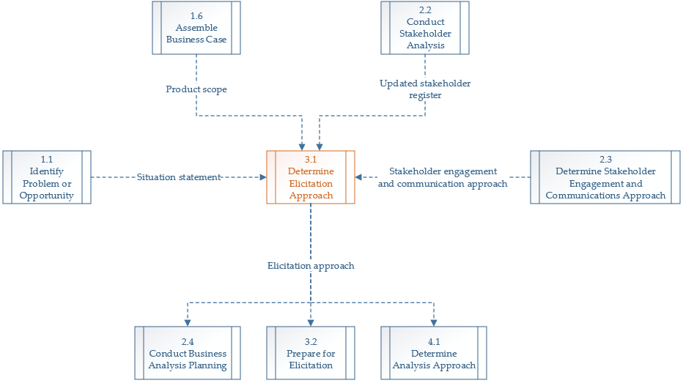

**Figure 3-2. Determine Elicitation Approach: Data Flow Diagram**

An elicitation plan is a device used by business analysts to “help formulate ideas about how to structure the elicitation activities.” The plan is not necessarily a formal document and can be created quickly. It can be documented or can be the thought process used to prepare for the forthcoming elicitation efforts.

The work needed to create the elicitation plan involves thinking through how to best coordinate and conduct elicitation across a project. Per the Project Management Institute, some of the elements in an elicitation plan include but are not limited to:

* **“What information to elicit.** What does the business analyst need to know in order to define the problem, solve the problem, or answer the question?
* **Where to find that information.** Where is that information located: in what document, from what source, in whose mind? Identify who has the information or where it is located.
* **How to obtain the information.** What method will be used to acquire the information from the source?
* **Sequencing the Elicitation Activities.** In what order should the elicitation activities be sequenced to acquire the needed information?

A well-thought-out approach to elicitation plan provides the following benefits:

* Clear idea of the necessary information to define a problem, effect an improvement, or produce a solution;
* Minimization of unnecessary elicitation activities;
* Valuable results from each elicitation activity;
* Efficient and predicable use of stakeholder time to elicit the information; and
* Better overall focus on the entire elicitation process.”

## Finding Information

Sources of information may be:

1. An individual in the business analyst plans to elicit information from,
2. A model, or
3. Other documented reference.

Individuals in the elicitation plan should be identified by role rather than name. When information cannot be provided by individuals, the business analyst should try to find similar sources, based on the enterprise. It is a good practice to try to identify at least two sources for each elicitation topic to avoid bias.

## Prepare for Elicitation

Elicitation preparation may be formal or informal. Elicitation preparation is the planning performed to conduct an effective elicitation session. The business analyst may create information preparation notes to organize and to help facilitate the session. Preparation notes can be used to measure the progress achieved in a session against what was planned to be achieved and can be used to adjust expectations for future sessions. Ideally, elicitation sessions will have an abundance of probing and investigative questions. The right question is not known until after a question is answered an analyzed. The more questions asked, the greater the chance to ask the right question.

### Example of Preparation Notes for an Elicitation Session

| **Objective** | Come to an agreement on what equipment will be moved. |
| --- | --- |
| **Participants** | Associate Director of UFIT Operations  Associate Director of UFIT Facilities  Director of UFIT Infrastructure and Communications Technology |
| **Questions** | * Will there be any new equipment purchased to replace the old equipment? * If there is new equipment, will it be delivered to the new or old address? * Will the move of the computer equipment be the responsibility of UFIT or the general moving company? * Will the employees be responsible for any part of the move, for example, moving personal items, or will these be boxed up and moved by the moving company? * What insurance will cover the equipment during the move? * Is there a specific order in which the equipment is required to be moved? |

Make sure to close each elicitation session with questions for the participants (e.g., Is there anything we missed or anything that we should have talked about but didn’t?). After an elicitation session and taking the time to analyze and consolidate the information, make sure to follow up with the participants by providing a one or two paragraph summary.

## Elicitation Techniques

A wide range of techniques is available for requirements elicitation, with each one having its own strengths and weaknesses. These techniques may be used alone or in combination with others to achieve the desired outcome. It is necessary to understand the characteristics of each technique before selecting and applying the appropriate ones to ensure an optimal exchange of information. ***Select at most three*** *of the following commonly used techniques for elicitation throughout the project life cycle and remove the extraneous ones below. Note that the descriptions of each technique below is sourced from the Project Management Institute’s glossary for accuracy and precision.*

* **Interviews.** An interview is a methodical approach used to elicit information from stakeholders by asking relevant questions and documenting the responses. During this activity, questions are posed to program and project participants to identify functions and capabilities that should exist in the product, service, or result. Interviews may be structured, where questions are prepared in advance of a meeting, or unstructured, where questions are asked in a free-flowing manner based on responses to previous questions.
* **Facilitated Workshops.** Facilitated workshops convene stakeholders or multidisciplinary teams in a focused and structured session to identify requirements, reconcile differences, and reach consensus among the participants. These interactive workshops enable discovery of requirements while resolving conflicts early in the project life cycle.
* **Focus Groups.** Focus groups assemble prequalified participants, such as subject matter experts, in a group setting to share their attitudes and expectations about a product, service, or result. The group members voice their opinions and provide clarity on specific topics. This technique provides qualitative feedback that can be further examined as requirements are analyzed.
* **Brainstorming.** Brainstorming is a group technique used to generate multiple ideas related to a subject. It uses the collective input from the group to understand different perspectives of a problem or solution and to build upon each other’s ideas. This method relies heavily on the contribution of its participants to gain valuable information regarding a specific topic. Other examples of group creativity techniques include use of the nominal group technique, ideal/mind-mapping, affinity diagram, and multicriteria decision analysis.
* **Questionnaires and Surveys.** Questionnaires and surveys are techniques used to quickly solicit and obtain information from many users. They involve prepared questions to elicit subjective and demographic data from respondents. The data is analyzed to extract relevant requirements or may be used to prepare for further elicitation. Questionnaires and surveys are most effective when quick responses are needed, and stakeholders are geographically dispersed. Questionnaires and surveys can be closed-ended or open-ended. Closed-ended questions provide the respondent with a predefined list of responses from which to choose. In contrast, open-ended questions allow the respondent to answer questions in his or her own words.
* **Document Analysis.** A substantial amount of information can be uncovered by reviewing and analyzing existing documentation. Document analysis inspects a wide range of materials, such as a glossary of terms, strategic and business plans, process flows, problem/issue logs, regulations, policies, and procedures to discover and/or verify requirements. This technique provides a good starting point for eliciting relevant product details. Using up-to-date and accurate documentation is important to safeguard against erroneous information.
* **Interface Analysis.** Interface analysis is used to define requirements by examining system interactions between users, processes, and other system components. It helps to establish relationships and boundaries by determining the input and output needs of each interfacing system. This method is useful for identifying additional stakeholders who may be impacted by changes to the system interfaces, as well as potential interoperability issues.
* **Prototypes.** Prototyping is a method of obtaining early feedback on requirements by providing a working model of the expected product before actual development. This model is used to progressively refine requirements by giving stakeholders an opportunity to test, experiment, and provide feedback. Prototyping is performed in an iterative manner that consists of prototype creation, evaluation, and revision. It continues until the requirements obtained from the prototyping is an evolutionary development process that transforms the requirements into a subset of functionality that provides value.
* **Observation.** Observation, also known as “job shadowing,” provides a direct way of viewing people in their environment to see how they perform their jobs or tasks and carry out processes within their environment. This technique is particularly helpful for eliciting tacit requirements that are difficult to verbalize.

The Elicitation Plan can be found within the project’s UFIT Business Analysis Workbook. To avoid duplication of documentation and effort, please provide a link to the project’s Business Analysist Workbook below.

[INSERT HYPERLINK HERE]

# Analysis Approach

Per the Project Management Institute, “Analysis is the process of examining, breaking down, synthesizing, and clarifying information to further understand, complete, and improve it. […]

Determine Analysis Approach is the process of thinking ahead about how analysis will be performed, including what will be analyzed; which models will be most beneficial to produce; and how requirements and other product information will be verified, validated, and prioritized. The key benefit of this process is that it supports a shared understanding of the business analysis work to be performed to develop the solution.” (Project Management Institute, Inc., 2017).



**Figure 4-1. Determine Analysis Approach: Inputs, Tools and Techniques, and Outputs**

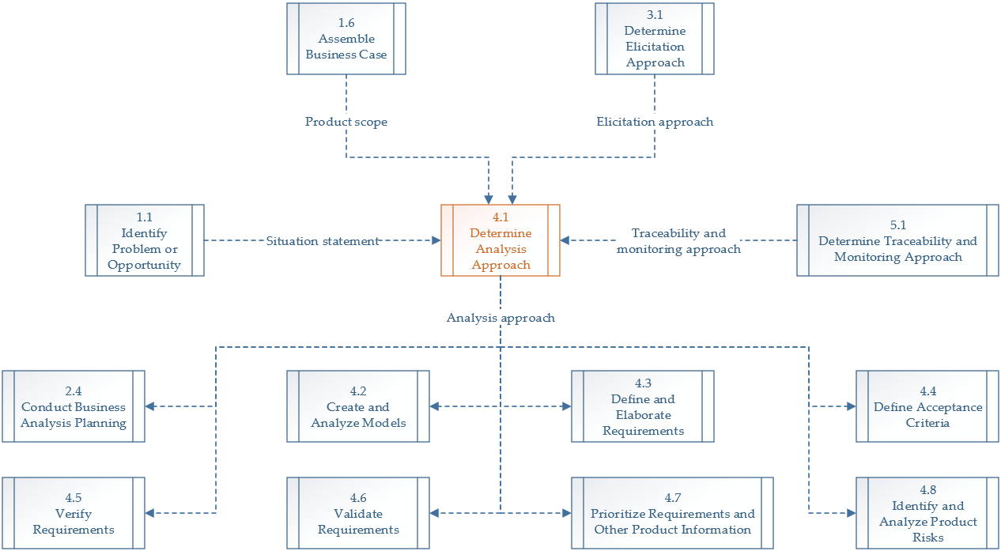

**Figure 4-2. Determine Analysis Approach: Data Flow Diagram**

It is pertinent that the business analyst identifies the different types of models they will use throughout their project analysis efforts, depending on the project’s needs. Determining the analysis approach should include:

* Which models will likely be most useful, when they would be developed and analyzed, and which stakeholders should be using and reviewing the models;
* When and how requirements elicitation, verification, validation, prioritization, and approval will occur, as well as requirement change control procedures;
* An approach for defining acceptance criteria; and
* An approach to identify and manage risks during analysis activities.

## Create and Analyze Models

Models are important inputs to business analysis activities that occur outside of the Create and Analyze Models process. They can be organized into five categories:

1. Scope Models, which bound the solution;
2. Process Models, which show how the solution will be used;
3. Rule Models, which provide a logical representation of the solution’s needs;
4. Data Models, which show data used in a process or system and its life cycle; and
5. Interface Models, which visually shows how users will interact with the solution.

By analyzing the solution from these five different views or categories of models, a business analyst can obtain a complete picture of the product.

| Category | Example Models | Example Models |
| --- | --- | --- |
| Scope Models | Models that structure and organize the features, functions, and boundaries of the business domain being analyze. | * Context diagram * Ecosystem map * Event list * Feature model * Goal and business objectives model * Organizational chart * Use case diagram |
| Process Models | Models that describe the business processes and ways in which stakeholders interact with those processes. | * Process flow * Use case * User story |
| Rule Models | Models of concepts and behaviors that define or constrain aspects of a business in order to enforce established business policies. | * Business rules catalog * Decision table * Decision tree |
| Data Models | Models that document the data used in a process or system and its life cycle. | * Data dictionary * Data flow diagram * Entity relationship diagram * State diagram * State table |
| Interface Models | Models that assist in understanding specific systems and their relationships within a solution and with users. | * Display-action-response model * Prototype * Report table * System interface table * User interface flow * Wireframe |

**Figure 4-3. Models Organized by Category.**

For this project, the business analyst shall develop and analyze the following models:

* [LIST MODELS HERE]

## Acceptance Criteria

Acceptance criteria are “the conditions that need to be met before a solution is accepted. They are used to measure whether a customer is satisfied with the solution built” (Project Management Institute, Inc., 2017). Determining the acceptance criteria involves reviewing requirements and analysis models with business stakeholders to identify how the business stakeholder would approve something as done. ***Select one*** *of the following acceptance criteria techniques for this project and remove the extraneous ones below. Note that the descriptions of each technique below is sourced from the Project Management Institute’s glossary for accuracy and precision.*

* **Behavior-Driven Development.** Behavior-driven development (BDD) is an approach that suggests that the team should begin with understanding how the user will use a product (its behavior), write tests for that behavior, and then construct solutions against the tests. Behavior-driven development encourages a conversation between the user or customer who needs to be satisfied with the solution and those who are implementing the solution. The conversation often leads to examples of real-life scenarios that the team uses to build a shared understanding. This approach is a continuation of test-driven development, which suggests that writing tests first will create better products with fewer defects. While this technique is popular in adaptive approaches, it can be applied in any life cycle approach.

The behavior-driven development approach includes a commonly accepted syntax to write acceptance criteria for user stories, the given-when-then format. The given-then-when format ensures that the business stakeholders should consider the preconditions of the user in the product, the triggers, and how the product should react in these conditions. Acceptance criteria are generally written as “Given <the precondition>, when <the user does something within the product>, then <the product reaction>.” Alternatively, any format can be used for acceptance criteria if the criteria include the preconditions and information necessary to test the criteria, the function being tested, and the expected post condition or results after the function is performed.

* **Definition of Done.** The definition of done (DoD) is a series of conditions that the entire team agrees to complete before an item is considered sufficiently developed to be accepted by the business stakeholders. The definition of done for a user story or iteration helps the project team know that the work is complete, so the team can move on to the next user story or iteration. Once an item meets the definition of done criteria, it is marked appropriately in any planning tools, such as project plans or requirements management tools. Definitions of done can be created at many levels of detail. They can be closely related to acceptance criteria, including using acceptance criteria in the definitions of done. They are often defined at the user story level, the iteration level, the release level, and the product level. The definition of done might include items such as:
  + Acceptance criteria are met;
  + Development, test, and defect standards are conformed to; and
  + High-level nonfunctional and usability requirements are met.

Definitions of done are written early in a portfolio, program, or project. The definition of done for any given user story, iteration, release, or solution is usually similar across the product or portfolio of products, or it can be specific to a low-level entity. For example, some user stories might warrant specific definitions of done. Definitions of done can evolve over time.

* **Story Elaboration.** Story elaboration is the process by which user stories are supplemented with additional information from conversations with business stakeholders, until they are sufficiently detailed for product development to begin work. In adaptive approaches, user stories are commonly written at a higher level of detail than functional and nonfunctional requirements, so story elaboration is the technique used to add the extra details for each story so that development teams have enough information to build the solution. Adaptive life cycles explicitly define acceptance criteria with concrete examples as part of the elaboration of a user story. Together, these details establish mutual agreement between business stakeholders and those responsible for developing the solution regarding what is required and how to know that the requirement has been met.

Story elaboration is primarily used in *adaptive* methodologies because too much information about a user story too early in the project can hinder the development team’s capability to negotiate priorities with the business and adapt to changes in the requirements. Design information and customer decisions are only added to the user story “just in time” for development to work on the user story. Story elaboration can take the form of further conversations or writing narratives around the user story, making design decisions, drafting wireframes or other analysis models, writing acceptance criteria, and documenting business rules, issues, constraints, and dependencies.

## Requirements Management

The requirements management plan describes how the requirement activities of the project will be planned and managed. It is highly influenced by whether the project management approach is predictive or adaptive. Initially, all requirements are collected through elicitation. Refer to Elicitation Approach for more information. UF’s Project Management Office recommends using UFIT’s Application Lifecycle Management (ALM) tool to document, track, manage, validate, and report on requirements. After requirements have been collected and placed in the ALM tool, the business analyst shall extract them into a formalized Requirements Specification document and review with all stakeholders. Once reviewed, it is presented to the sponsor and stakeholders for approval.

If the project management approach is predictive, then requirements approval may be formal and require a signature. Otherwise, they are generally informal and only require verbal acceptance. If the approval was formal, a signed copy of the Requirements Specification documentation should be stored in ALM, SharePoint Online, and/or the Project and Portfolio Management (PPM) tools for the project.

### Verify Requirements

Requirements verification is the process of reviewing requirements to ensure the requirements are constructed properly and are error free. It involves conducting peer reviews and identifying inconsistencies to meet quality standards. Per the Project Management Institute, the following characteristics are present in all well-written, high-quality requirements:

* **Unambiguous.** The requirement has a clear meaning.
* **Consistent.** The requirement does not contradict nor duplicate other requirements.
* **Correct.** The requirement accurately represents the functionality to be built.
* **Complete.** The requirement includes the necessary information to design, build, and test the solution.
* **Measurable.** The requirement can be proven or verified through numeric evidence.
* **Feasible.** The requirement can be implemented within the known constraints.
* **Traceable.** The requirement has a unique identifier.
* **Precise.** The requirement states exactly what the solution to the business problem is.
* **Testable.** The requirement should be written in a way that allows it to be tested.

### Validate Requirements

Requirements validation is used to evaluate that all requirements accurately reflect the intent of the stakeholder, thereby ensuring requirements meet stakeholder expectations. Validation is typically performed by conducting a walkthrough of the requirements with stakeholders to confirm the requirements as stated are valid and will deliver the anticipated value. ***Select at most two*** *validation techniques for this project and remove the extraneous ones below. Note that the descriptions of each technique below is sourced from the Project Management Institute’s glossary for accuracy and precision.*

* **Delphi.** A consensus-building technique that conducts a survey to take anonymous input from subject matter experts (SMEs) and consolidates that input through a facilitator. Each round of input is discussed by the team to gain understanding, and then the survey is performed again. In this technique, each stakeholder provides a prioritization for the requirements set using the prioritization scheme chosen, and then the stakeholders meet to discuss until the group agrees on the prioritization. This method is intended to reduce peer pressure or groupthink in the prioritization process or to avoid the team giving in to a voice of authority with whom they may disagree.
* **Goal Model and Business Objectives Model.** The goal and business objectives models describe the business objectives the solution is meant to achieve, along with the high-level features for the solution. Either model can be helpful for mapping requirements or user stories through features or other models back to business objectives to ensure that requirements are in alignment with business objectives.
* **Traceability Matrix.** A grid that allows for linkages between objects. A traceability matrix can be used to trace requirements to other types of requirements in the hierarchy – for example, from business requirements to solution requirements. It can be used to trace requirements to analysis models or to downstream items such as test cases. During Validate Requirements, a traceability matrix is primarily used to trace the requirements to analysis models and ultimately to business objectives that each requirement supports. This analysis ensures that each business objective has coverage by the requirements and that each requirement traces directly back to support a business objective. Any requirements that cannot be traced back to business objectives are likely not valid and can be cut from the scope.
* **Walkthroughs.** Walkthroughs are used to review the requirements with the stakeholders and to receive confirmation that the requirements as stated are valid. Validated requirements accurately reflect what the stakeholders are asking the development team to build. Walkthroughs entail holding a meeting or meetings to review the requirements as a group, to ensure that there is a common understanding of the requirements and whether they are needed. Typically, a business analyst will send the requirements to the business stakeholders to review individually before the walkthrough takes place. Walkthroughs that are specifically focused on reviewing requirements are often called requirements walkthroughs.

### Prioritize Requirements and Other Product Information

The analysis approach identifies which prioritization methods the team has agreed to use and when. ***Select at most two*** *of the following commonly used schemes to use for prioritization throughout the project and remove the extraneous ones below. Note that the descriptions of each technique below is sourced from the Project Management Institute’s glossary for accuracy and precision.*

* **Buy a feature.** A type of collaborative game used to enable a group of stakeholders to agree on prioritization by providing each stakeholder with an amount of pretend money to buy his or her choice of features, splitting the money received across features, however desired. The features are prioritized by counting the total money spent per feature by all stakeholders. The features that receive the most money from the participants are considered the most valuable and highest-prioritized features.
* **Delphi.** A consensus-building technique that conducts a survey to take anonymous input from subject matter experts (SMEs) and consolidates that input through a facilitator. Each round of input is discussed by the team to gain understanding, and then the survey is performed again. In this technique, each stakeholder provides a prioritization for the requirements set using the prioritization scheme chosen, and then the stakeholders meet to discuss until the group agrees on the prioritization. This method is intended to reduce peer pressure or groupthink in the prioritization process or to avoid the team giving in to a voice of authority with whom they may disagree.
* **Minimum viable product (MVP).** A prioritization mechanism used to define the scope of the first release of a solution to customers by identifying the fewest number of features or requirements that would constitute a solution from which the customer would obtain value. The minimum viable product may not include the items that bring the most quantifiable value to the business, bur rather a set of items that accelerates time to market for solutions by focusing on releasing the fundamental pieces of a product. Additional features are added in future releases that deliver additional business value. The point of using this technique is to realize some business value faster than waiting for a full product to be built and to learn about the product early on to guide future development. Minimum marketable features (MMF) is a related prioritization mechanism in which the smallest piece of functionality that still delivers value to the customer is identified.
* **MoSCoW.** A technique that categorizes each requirement into one of the following groups:
  + *Must have* (fundamental to solution success),
  + *Should have* (important, but the solution’s success does not rely on the requirement),
  + *Could have* (can easily be left out without impacting the solution), or
  + *Won’t have* (not delivered this time around).
* **Multivoting.** A method also called dot voting because it can be performed by providing stakeholders with a prescribed number of colored dots and allowing them to vote by placing their dots on the requirements that they feel are the most important. All votes are aggregated, and requirements are ranked by the number of dots/votes received. This method is like “buy a feature.”
* **Purpose alignment model.** A technique that provides a framework for categorizing business options by their purpose. It supports aligning business decisions with business purposes. The purpose of each option is identified by considering how mission critical it is and how much competitive advantage each will provide to the organization. While this technique is primarily intended as a basis for making strategic or high-level product decisions, some organizations also use it to analyze and facilitate discussions about product requirements and the value each provides, which, in turn, becomes a springboard for prioritization discussions about product features and requirements.
* **Timeboxing.** An estimation or planning technique that can be used during prioritization by setting a strict time limit and prioritizing only the work that the team can complete in that duration of time. Timeboxing is usually used in conjunction with a second prioritization scheme to understand the highest-prioritized requirements to pull into the time-box.
* **Weighted ranking.** A method that first requires decision criteria to be identified and weighted. Then each item is rated by scoring how well the option meets the criteria independent of other options. Ratings are multiplied by the weights and summed to arrive at the score for each item and the overall rankings.
* **Weighted shortest job first (WSJF).** A method used primarily in adaptive frameworks to rank user stories based on more dimensions than just business value and effort. WSJF works by having business value, time criticality, risk reduction or opportunity enablement, and effort all sized using something like a Fibonacci sequence used in estimation poker. A formula is used to calculate a weighted value for each user story:

## Product Risk Management

It is pertinent that the business analyst uncovers and examines assumptions and uncertainties that could affect solution success, development, and outcomes. Per the Project Management Institute, identifying and analyzing product risks includes the following activities:

* Identifying product risks;
* Performing qualitative risk analysis;
* Performing quantitative risk analysis; and
* Planning risk responses.

| Strategies for Negative Risks | Strategies for Positive Risks |
| --- | --- |
| * Avoid. * Mitigate. * Transfer. * Accept. | * Exploit. * Share Ownership. * Enhance. * Accept. |

### Identify and Analyze Product Risks: Tools and Techniques

Documentation relating to portfolio, program, project, or product risk should be stored within UFIT’s Risk Management (Archer), SharePoint Online, and Application Lifecycle Management (ALM) tools. ***Select up to three*** *risk identifying techniques to use throughout the project life cycle and remove the extraneous ones below. Note that the descriptions of each technique below is sourced from the Project Management Institute’s glossary for accuracy and precision.*

* **Context Diagram.** A scope model that shows all the direct system and human interfaces to systems within a solution. A context diagram clearly depicts the in-scope systems and any inputs or outputs, including the systems or actors providing or receiving them. These models can be used to identify product risks or failure points by analyzing the interfaces.
* **Ecosystem Map.** A scope model that shows all the relevant systems, the relationships between each system, and optionally, any data objects passed between them. A business analyst would use an ecosystem map for product risk analysis in the same way that a context diagram would be used. Ecosystem maps may be used to identify product risks or potential failure points, through analyzing the interfaces and objects passed between the systems.
* **Elicitation Techniques.** Elicitation techniques are used to draw information from sources. Product risks are uncovered through elicitation; thus, any of the elicitation techniques can be used to identify and analyze product risks.
* **Estimation Techniques.** Estimation techniques are used to provide a quantitative assessment of likely amounts or outcomes. Various estimation techniques can be used to quantify the probability and impact of product risks.
* **Organizational Chart.** Organizational charts are models that depict the reporting structure within an organization or within a part of an organization. These models can be used to identify risks related to stakeholder groups – for example, when there are stakeholder groups identified that may impact business analysis activities. Organizational charts can also be used to identify who should own the product risk response plans.
* **Process Flows.** Process flows visually document the steps or tasks that people perform in their jobs or when they interact with a product. These models may be used to identify product risks or potential failure points by analyzing process steps, decision points, and handoffs between different actors in a process.
* **Product Backlog.** The list of all product backlog items, typically user stories, requirements, or features, that need to be delivered for a solution. Projects that employ adaptive approaches use the product backlog as part of the requirements package. When needed, tasks called spikes or risk spikes can be added to the product backlog to evaluate risks. The items in the product backlog are ranked in order of business values or importance to the customer and are continuously updated throughout a product’s life cycle or a project’s duration.
* **Risk Burndown Chart.** Burndown charts are used to communicate progress over time. On adaptive projects, risk burndown charts can be used to show the status of risks across iterations. The sum of exposures (probability multiplied by impact) across all product risks is mapped for each iteration. Ideally, the burndown chart should show a downward slope when connecting the data points to indicate that product risk exposures are decreasing as iterations progress.
* **Risk Register.** A tool used to support analysis of product risks. Product risks are logged with corresponding details, which may include the following:
  + *Risk ID.* Unique number used to identify the risk.
  + *Risk description.* Textual description of the risk.
  + *Date logged.* Date when the risk was identified.
  + *Risk owner.* Person responsible for monitoring the risk.
  + *Status.* State of the risk – for example, open or closed.
  + *Updates.* Progress information on the risk.
  + *Impact rating.* Numerical rating representing the severity if the risk event were to occur.
  + *Probability rating.* Numerical rating representing the probability of the risk event occurring.
  + *Exposure.* Impact multiplied by probability.
  + *Trigger.* Signs that warn that the risk is about to occur or has already occurred.
  + *Risk response.* Actions that can be taken to proactively address the risk.
  + *Risk response owner.* Person responsible for executing the risk response.
  + *Workaround.* Actions to be performed if the risk were to occur.

The business analyst and portfolio, program, or project manger may opt to produce a consolidated risk register. Risks can be identified during iteration or daily planning.

* **Root Cause and Opportunity Analysis.** Root cause analysis is used to determine the basic underlying reason that causes a variance, defect, or risk. Opportunity analysis is used to study the major facets of a potential opportunity to determine the possible changes in products offered to enable its achievement. Root cause and opportunity analysis can be used to develop response plans to proactively address negative product risks or take advantage of potential opportunities.
* **SWOT Analysis.** A technique for analyzing the (S) strengths and (W) weaknesses of an organization, project, or option, and the (O) opportunities and (T) threats that exist externally. SWOT analysis can be used to identify potential product risks in the form of positive risks (opportunities) or negative risks (threats).

# Traceability and Monitoring Approach

Determine Traceability and Monitoring Approach is the process of considering how traceability will be performed on the portfolio, program, project, or product, and defining how requirement changes will be managed.



**Figure 5-1. Determine Traceability and Monitoring Approach: Inputs, Tools and Techniques, and Outputs**

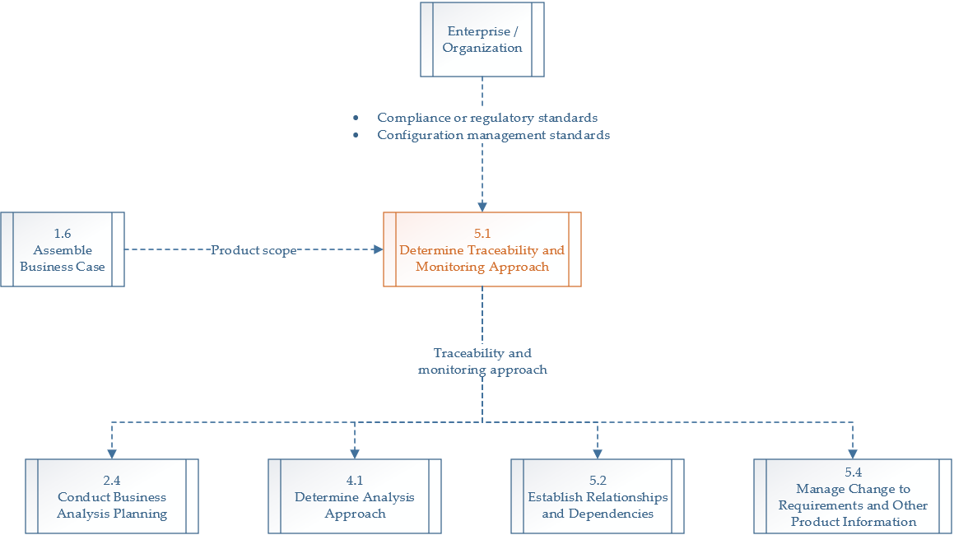

**Figure 5-2. Determine Traceability and Monitoring Approach: Data Flow Diagram**

The traceability and monitoring approach defines change management procedures for the portfolio, program, project, or product. An appropriately sized traceability and monitoring approach:

* Minimizes the likelihood of missing requirements;
* Avoids time-consuming and wasteful maintenance;
* Ensures that changes align with the project objectives;
* Makes it simple to implement changes; and
* Aligns to organizational standards.

Components of the traceability and monitoring approach *related to traceability* may include:

* Types of objects to trace;
* Level of detail needed;
* Relationships that will be maintained;
* Where relationships will be tracked; and
* Requirement statuses used.

If UFIT’s Enterprise Systems organization owns the product, then the Project Management Office highly recommends using a Requirements Management tool, such as UFIT’s Application Lifecycle Management (ALM) service, for requirements traceability and monitoring to establish relationships and dependencies. ***Select at least one*** *of the following techniques this project will use and remove the extraneous ones below. Note that the descriptions of each technique below is sourced from the Project Management Institute’s glossary for accuracy and precision.*

* **Feature Model.** A scope model that visually represents all the features of a solution arranged in a tree or hierarchical structure. The feature model shows relationships between features and which features are sub features of other ones. The feature model helps teams establish and communicate relationships between different features.
* **Requirements Management Tool.** A requirements management tool, such as UFIT’s Application Lifecycle Management (ALM) environment, allow requirements and other product information to be captured and stored in a repository. These tools often have functionality to:
  + Maintain audit trails and perform version control to assist with change management,
  + Facilitate review and approval processes through workflow functionality,
  + Generate visual models and interactive prototypes,
  + Support team collaboration,
  + Integrate with office productivity software for easy imports and exports,
  + Track and report on requirements status, and
  + Assist in performing detailed traceability based on trace links established in the tool.

Requirements management tools catered to adaptive projects may include additional functionality to create and manage product and iteration backlogs, and product burndown charts. A requirements management tool does not help define high-quality product information, but can assist with the process of storing, managing, and maintaining product information.

* **Story Mapping.** A technique used to sequence user stories, based upon their business value and the order in which their users typically perform them, so that teams can arrive at a shared understanding of what will be built. Horizontally, the story map shows what will be delivered within an iteration, and vertically the story map depicts higher-level groupings or categories of user stories. User stories may be grouped by different categories such as functionality, themes, or application. Story mapping can be used to establish relationships between user stories to iterations and the higher-level categories.
* **Story Slicing.** A technique used to split requirements or user stories from a higher level to a lower level. Story slicing is a means of establishing relationships between requirements as lower-level requirements or user stories are subsets of higher-level requirements or epics.

**Traceability Matrix.** A grid that allows for linkages between objects. A traceability matrix can be used to trace requirements to other types of requirements in the hierarchy – for example, from business requirements to solution requirements. It can be used to trace requirements to analysis models or to downstream items such as test cases. During Validate Requirements, a traceability matrix is primarily used to trace the requirements to analysis models and ultimately to business objectives that each requirement supports. This analysis ensures that each business objective has coverage by the requirements and that each requirement traces directly back to support a business objective. Any requirements that cannot be traced back to business objectives are likely not valid and can be cut from the scope. If the PMO Business Analysts decides to manage requirements manually using a Traceability Matrix, one can be found within the project’s UFIT Business Analysis Workbook ([INSERT HYPERLINK HERE]).

# Solution Evaluation Approach

Determining the Solution Evaluation Approach should include:

* Planning when and how often solution evaluation activities should be completed;
* Planning which techniques will be used;
* Planning how the results will be analyzed and reported;
* Planning how progress will be communicated to stakeholders; and
* Planning which metrics will be used to evaluate and measure benefits realization.



**Figure 6-1. Determine Solution Evaluation Approach: Inputs, Tools and Techniques, and Outputs**

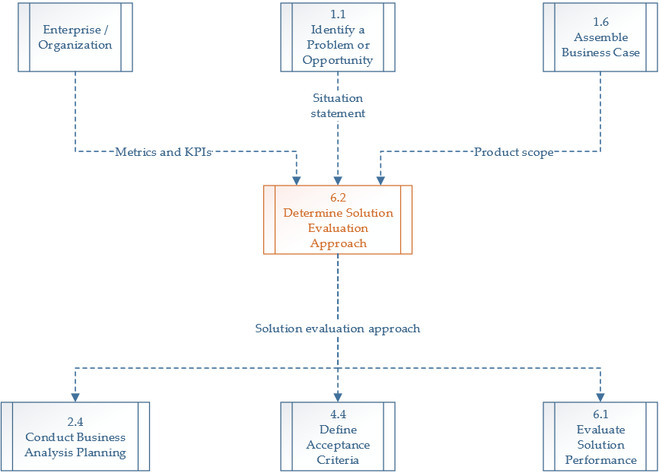

**Figure 6-2. Determine Solution Evaluation Approach: Data Flow Diagram**

***Select one*** *technique to determine the solution evaluation approach and remove the extraneous ones below. Note that the descriptions of each technique below is sourced from the Project Management Institute’s glossary for accuracy and precision.*

* **Elicitation Techniques.** Elicitation techniques are used to draw information from sources and can be used to identify existing metrics or potential new metrics for determine solution acceptance or evaluation whether business value has been delivered. They are also helpful to identify ideas about how a solution can be evaluated. A few common elicitation techniques that can support determining the solution evaluation approach are interview, facilitated workshops, and document analysis. See Section 3.3 (Elicitation Techniques) for more information.
* **Group Decision-Making Techniques.** Methods that can be used in a group setting to bring participants to a final decision on an issue or topic under discussion. Decision-making techniques are used to reach consensus about the solution evaluation approach. For example, teams need to reach decisions about which metrics to collect, the value of information against costs to obtain it, which of the proposed metrics to use, and the frequency of collecting metrics.
* **Prioritization Schemes.** See Section 4.3.3 (Prioritize Requirements and Other Product Information) for more information.
* **Retrospectives and Lessons Learned.** Retrospectives and lessons learned leverage past experiences to plan. As part of devising a solution evaluation approach, retrospectives and lessons learned can be used to learn about the ease of collecting and analyzing different types of metrics and the effectiveness of different evaluation techniques.

A release decision often includes either formal or informal sign-off.

# References

Project Management Institute, Inc. (2015). *Business Analysis for Practitioners: A Practice Guide.* Newtown Square, Pennsylvania: Project Management Institute, Inc.

Project Management Institute, Inc. (2016). *Requirements Management: A Practice Guide.* Newtown Square, Pennsylvania: Project Management Institute, Inc.

Project Management Institute, Inc. (2017). *The PMI Guide to Business Analysis.* Newtown Square, Pennsylvania: Project Management Institute, Inc.

# Sign-off